**Program #1:**

**Source Code:**

PrimaryMission() {

unit i,j,n;

unit temp;

unit choice=0;

go {

commence;

post("Enter any number : ");

capture(#n);

phase(n <= 0) {

post("Enter POSITIVE number : ");

capture(#n);

}

inquire(i=0;i<n;i++) {

inquire(j=0;j<n;j++) {

temp = n - i -1;

inorder((i==j) || (j==temp)) {

post(" *");

}

order {

post(" ");

}

}

post("\n");

}

go {

company ch;

post("\n\n\t\t\tTRY AGAIN? [Y] Yes or [N] No: ");

capture(#ch);

inorder((ch = = "Y") || (ch = = "y")) {

i=0;

j=0;

n=0;

temp=0;

choice = 1;

}

otherorder((ch = = "N") || (ch = = "n")) {

choice = 0;

}

order {

post("\n\t\t\tError Input!");

choice = 3;

}

} phase(choice = = 3);

} phase(choice != 0);

post("\n\t\t\tGOODBYE!!");

} deploy();

**Print Screen:**

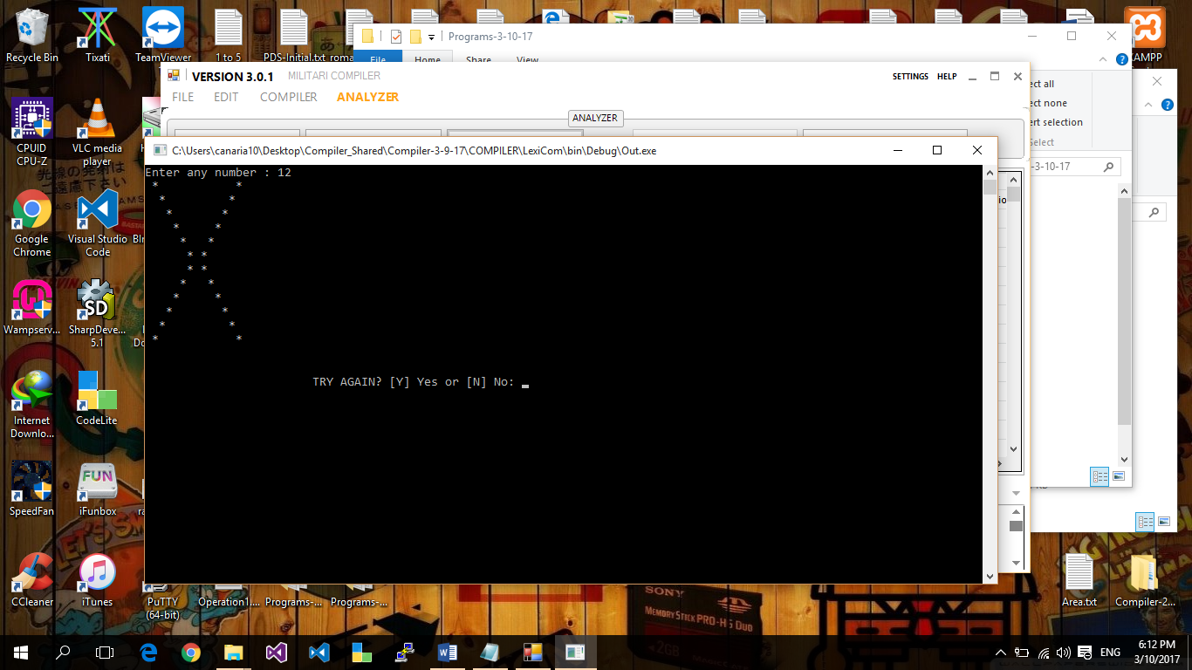

**Program # 2:**

**Source Code:**

PrimaryMission() {

unit i, j, n,k,temp,temp2,temp3,temp4;

unit choice=0;

go {

commence;

post("Enter value of n : ");

capture(#n);

phase(n > 50) {

post("Must not Exceeded to 50!\n");

post("Enter value of n : ");

capture(#n);

}

temp=n/2;

post(" ");

inquire(k=temp; k<=n; k++) {

k=k+2;

temp2=n-k;

inquire(j=1; j<temp2; j++) {

j=j+2;

post(" ");

}

inquire(j=1; j<=k; j++) {

post("*");

}

inquire(j=1; j<=temp2; j++) {

post(" ");

}

inquire(j=1; j<=k; j++) {

post("*");

}

post("\n");

}

inquire(i=n; i>=1; i--) {

inquire(j=i; j<n; j++) {

post(" ");

}

temp3=(i*2);

post(" ");

inquire(j=1; j<=temp3; j++) {

post("*");

}

post("\n");

}

go {

company ch;

post("\n\n\t\t\tTRY AGAIN? [Y] Yes or [N] No: ");

capture(#ch);

inorder((ch = = "Y") || (ch = = "y")) {

i=0;

j=0;

n=0;

k=0;

temp=0;

temp2=0;

temp3=0;

temp4=0;

choice = 1;

}

otherorder((ch = = "N") || (ch = = "n")) {

choice = 0;

}

order {

post("\n\t\t\tError Input!");

choice = 3;

}

} phase(choice = = 3);

} phase(choice != 0);

post("\n\t\t\tGOODBYE!!");

} deploy();

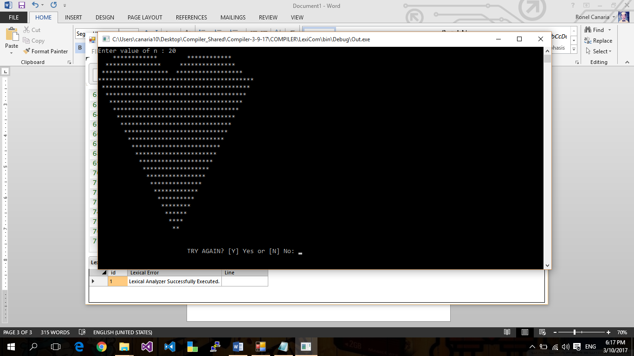**Print screen:**

**Program # 3:**

**Source Code:**

PrimaryMission() {

unit i,j,k,n,temp=0;

unit choice=0;

go {

commence;

post("Enter the Value for n : ");

capture(#n);

temp=temp-n;

inquire(i=temp;i<=n;i++) {

k=i;

inorder(k<0) {

k= k* ~1;

}

inquire(j=0;j<=n;j++) {

inorder(k>=j) {

post("* ");

}

order {

post(" ");

}

}

post("\n");

}

go {

company ch;

post("\n\n\t\t\tTRY AGAIN? [Y] Yes or [N] No: ");

capture(#ch);

inorder((ch = = "Y") || (ch = = "y")) {

i=0;

j=0;

k=0;

n=0;

temp=0;

choice = 1;

}

otherorder((ch = = "N") || (ch = = "n")) {

choice = 0;

}

order {

post("\n\t\t\tError Input!");

choice = 3;

}

} phase(choice = = 3);

} phase(choice != 0);

post("\n\t\t\tGOODBYE!!");

} deploy();

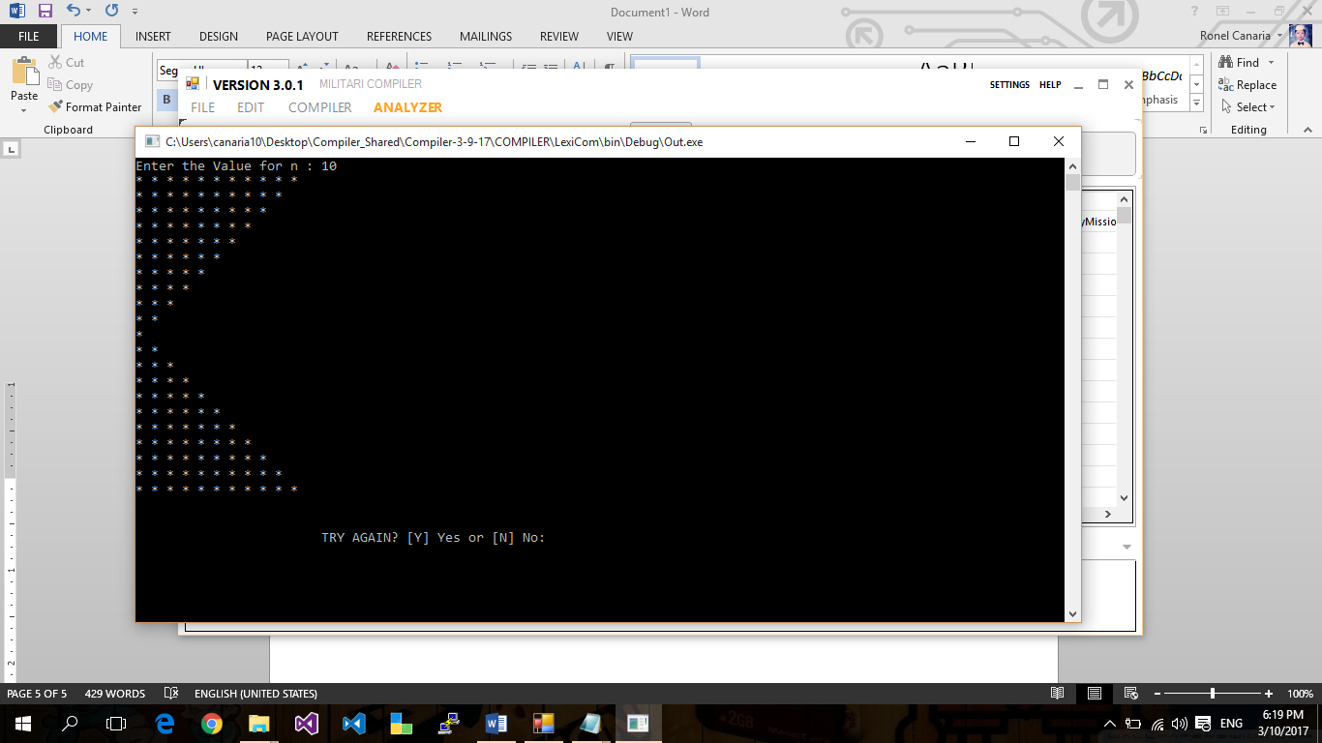**Print screen:**

**Program # 4:**

**Source Code:**

PrimaryMission() {

unit i,j,k,n,temp;

unit choice=0;

go {

commence;

post("Enter Number : ");

capture(#n);

inquire(i=1;i<=n;i++) {

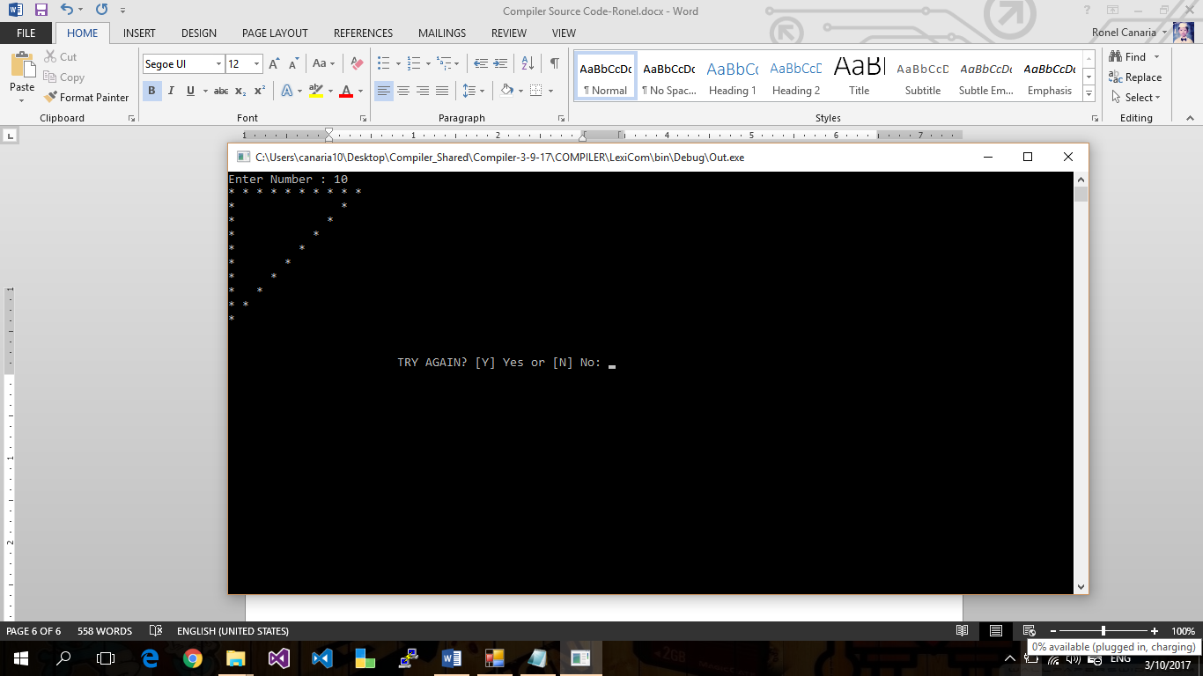inquire(j=1;j<=n;j++) {

temp = n + 1-i;

inorder(j <= temp) {

inorder((i = =1) || (j = = 1) || (j = = temp)) {

post("* ");

}

order {

post(" ");

}

}

}

post("\n");

}

go {

company ch;

post("\n\n\t\t\tTRY AGAIN? [Y] Yes or [N] No: ");

capture(#ch);

inorder((ch = = "Y") || (ch = = "y")) {

i=0;

j=0;

k=0;

n=0;

temp=0;

choice = 1;

}

otherorder((ch = = "N") || (ch = = "n")) {

choice = 0;

}

order {

post("\n\t\t\tError Input!");

choice = 3;

}

} phase(choice = = 3);

} phase(choice != 0);

post("\n\t\t\tGOODBYE!!");

} deploy();

**Print Screen:**

**Program # 5:**

**Source Code:**

PrimaryMission() {

unit i,j,k,num,temp=0;

unit choice=0;

go {

commence;

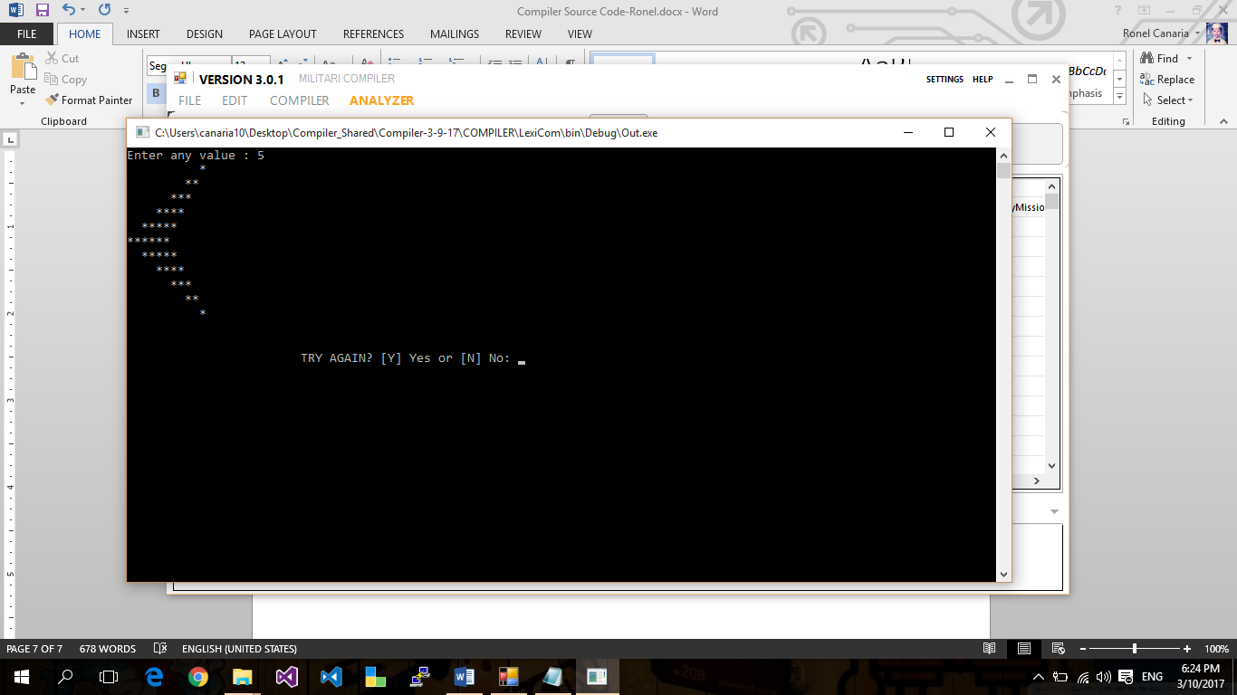post("Enter any value : ");

capture(#num);

temp=temp-num;

inquire(i=temp;i<=num;i++) {

k=i;

inorder(k<0) {

k = k * ~1;

}

inquire(j = 0; j <= num; ++j) {

inorder(j<k) {

post(" ");

}

order {

post("*");

}

}

post("\n");

}

go {

company ch;

post("\n\n\t\t\tTRY AGAIN? [Y] Yes or [N] No: ");

capture(#ch);

inorder((ch = = "Y") || (ch = = "y")) {

i=0;

j=0;

k=0;

num=0;

temp=0;

choice = 1;

}

otherorder((ch = = "N") || (ch = = "n")) {

choice = 0;

}

order {

post("\n\t\t\tError Input!");

choice = 3;

}

} phase(choice = = 3);

} phase(choice != 0);

post("\n\t\t\tGOODBYE!!");

} deploy();

**Print Screen:**

**Program # 6:**

**Source Code:**

PrimaryMission() {

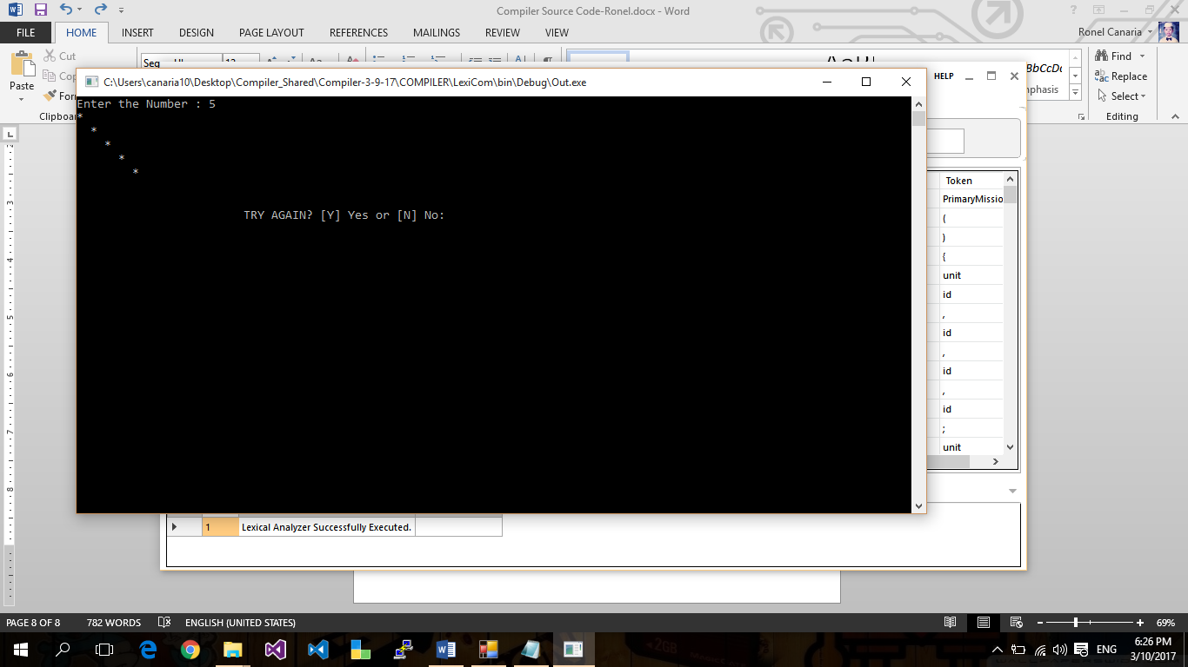unit i,j,k,num;

unit choice=0;

go {

commence;

post("Enter the Number : ");

capture(#num);

inquire(i=1;i<=num;i++) {

inquire(j=1;j<=num;j++) {

inorder(i==j) {

post("* ");

}

order {

post(" ");

}

}

post("\n");

}

go {

company ch;

post("\n\n\t\t\tTRY AGAIN? [Y] Yes or [N] No: ");

capture(#ch);

inorder((ch = = "Y") || (ch = = "y")) {

i=0;

j=0;

k=0;

num=0;

choice = 1;

}

otherorder((ch = = "N") || (ch = = "n")) {

choice = 0;

}

order {

post("\n\t\t\tError Input!");

choice = 3;

}

} phase(choice = = 3);

} phase(choice != 0);

post("\n\t\t\tGOODBYE!!");

} deploy();

**Print Screen:**

**Program # 7:**

**Source Code:**

unit arr1[100];

PrimaryMission() {

unit i, mx, mn, n;

unit choice=0;

go {

commence;

post("\n\nFind maximum and minimum element in an array :\n");

post("--------------------------------------------------\n");

post("Input the number of elements to be stored in the array :");

capture(#n);

post("Input" + n + "elements in the array :\n");

inquire(i=0;i<n;i++) {

post("element - " + i + ": ");

capture(#arr1[i]);

}

mx = arr1[0];

mn = arr1[0];

inquire(i=1; i<n; i++) {

inorder(arr1[i] > mx) {

mx = arr1[i];

}

inorder(arr1[i] < mn) {

mn = arr1[i];

}

}

post("Maximum element is : " + mx + "\n");

post("Minimum element is : " + mn + "\n\n");

go {

company ch;

post("\n\n\t\t\tTRY AGAIN? [Y] Yes or [N] No: ");

capture(#ch);

inorder((ch = = "Y") || (ch = = "y")) {

i=0;

mx=0;

mn=0;

n=0;

choice = 1;

}

otherorder((ch = = "N") || (ch = = "n")) {

choice = 0;

}

order {

post("\n\t\t\tError Input!");

choice = 3;

}

} phase(choice = = 3);

} phase(choice != 0);

post("\n\t\t\tGOODBYE!!");

} deploy();

**Print Screen:**

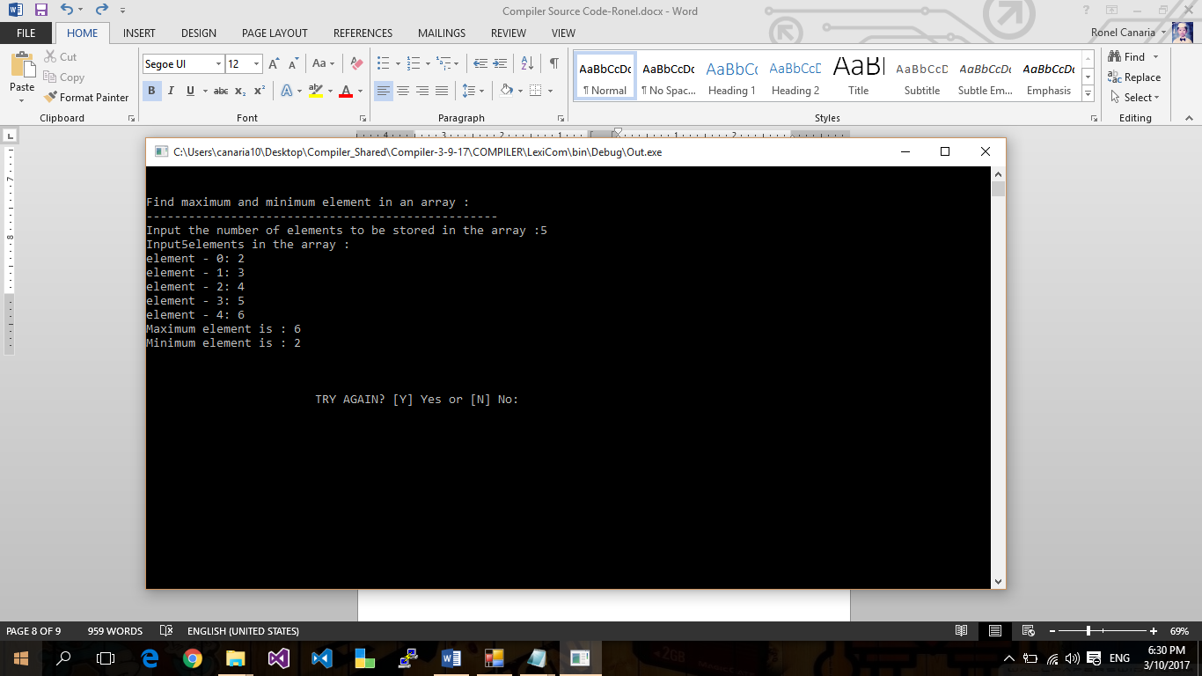

**Program # 8:**

**Source Code:**

unit getNextValue(unit aNum) {

unit i;

i = aNum;

unit temp;

temp = i%2;

inorder(temp = = 0) {

i = i/2;

}

order {

i = 3 * i + 1;

}

backup(i);

}

miss getHailstone(unit aNum) {

unit hlSe;

hlSe = aNum;

unit temp;

inorder(hlSe = = 1) {

post(hlSe + " ");

}

order {

post(" " + hlSe + " ");

temp = getNextValue(hlSe);

getHailstone(temp);

}

}

unit countLength(unit aNum) {

unit hlSe;

hlSe = aNum;

unit cnt = 0;

unit temp;

inorder(hlSe = = 1) {

cnt = 1;

}

order {

temp = getNextValue(hlSe);

cnt = cnt + countLength(temp);

}

backup(cnt);

}

PrimaryMission() {

unit aNum;

unit temp;

unit choice=0;

go {

commence;

post("\n\n Recursion : Hailstone Sequence of a given number upto 1 : \n");

post("-------------------------------------------------------------- \n");

post(" Input any number (positive) to start for Hailstone Sequence : ");

capture(#aNum);

phase(aNum <= 0) {

post(" Input any number (*positive) to start for Hailstone Sequence : ");

capture(#aNum);

}

post("\n The hailstone sequence starting at " + aNum + " is : \n");

getHailstone(aNum);

post("\n\n");

temp = countLength(aNum);

post(" The length of the sequence is " + temp + "\n\n");

go {

company ch;

post("\n\n\t\t\tTRY AGAIN? [Y] Yes or [N] No: ");

capture(#ch);

inorder((ch = = "Y") || (ch = = "y")) {

aNum=0;

temp=0;

choice = 1;

}

otherorder((ch = = "N") || (ch = = "n")) {

choice = 0;

}

order {

post("\n\t\t\tError Input!");

choice = 3;

}

} phase(choice = = 3);

} phase(choice != 0);

post("\n\t\t\tGOODBYE!!");

} deploy();

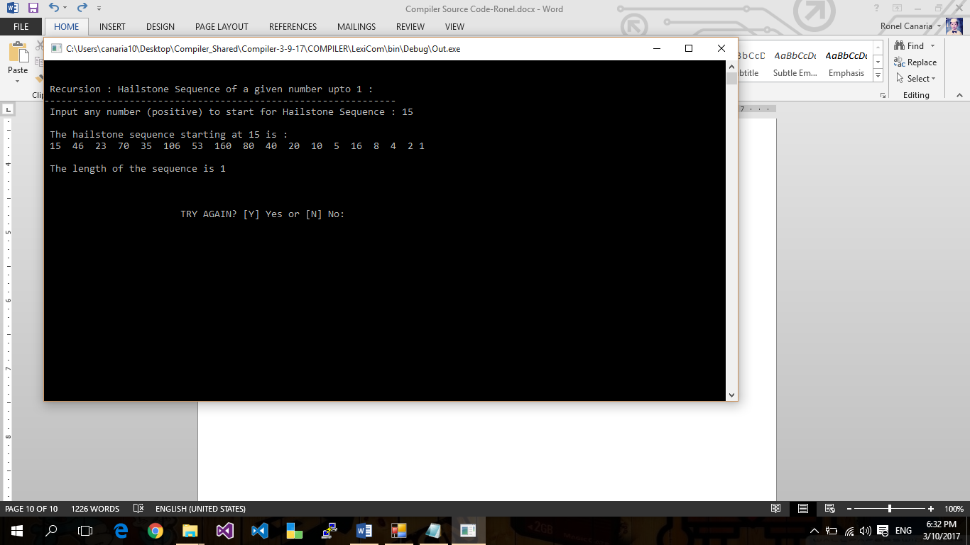**Print Screen:**

**Program # 9:**

**Source Code:**

PrimaryMission() {

unit cp,sp, amt;

unit choice=0;

go {

commence;

post("Enter cost price: ");

capture(#cp);

post("Enter selling price: ");

capture(#sp);

inorder(sp > cp) {

amt = sp - cp;

post("Profit = " + amt);

}

otherorder(cp > sp) {

amt = cp - sp;

post("Loss = " + amt);

}

order {

post("\nNo Profit No Loss.");

}

go {

company ch;

post("\n\n\t\t\tTRY AGAIN? [Y] Yes or [N] No: ");

capture(#ch);

inorder((ch = = "Y") || (ch = = "y")) {

cp=0;

sp=0;

amt=0;

choice = 1;

}

otherorder((ch = = "N") || (ch = = "n")) {

choice = 0;

}

order {

post("\n\t\t\tError Input!");

choice = 3;

}

} phase(choice = = 3);

} phase(choice != 0);

post("\n\t\t\tGOODBYE!!");

} deploy();

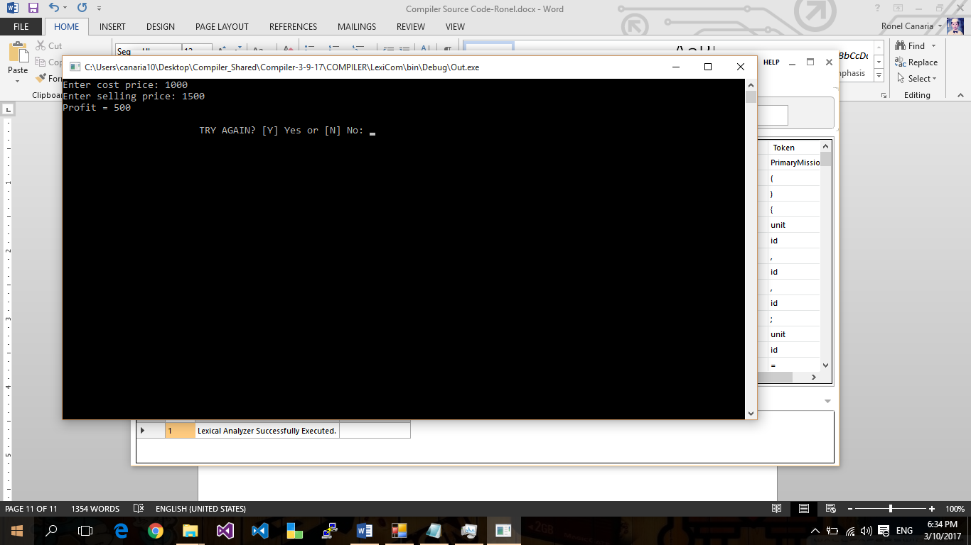**Print Screen:**

**Program #10:**

**Source Code:**

PrimaryMission() {

unit a, b, c;

unit choice=0;

go {

commence;

post("Enter three sides of triangle: ");

capture(#a);

capture(#b);

capture(#c);

inorder((a==b) & (b==c)) {

post("Equilateral triangle.");

}

otherorder((a==b) || (a==c) || (b==c)) {

post("Isosceles triangle.");

}

order {

post("Scalene triangle.");

}

go {

company ch;

post("\n\n\t\t\tTRY AGAIN? [Y] Yes or [N] No: ");

capture(#ch);

inorder((ch = = "Y") || (ch = = "y")) {

a=0;

b=0;

c=0;

choice = 1;

}

otherorder((ch = = "N") || (ch = = "n")) {

choice = 0;

}

order {

post("\n\t\t\tError Input!");

choice = 3;

}

} phase(choice = = 3);

} phase(choice != 0);

post("\n\t\t\tGOODBYE!!");

} deploy();

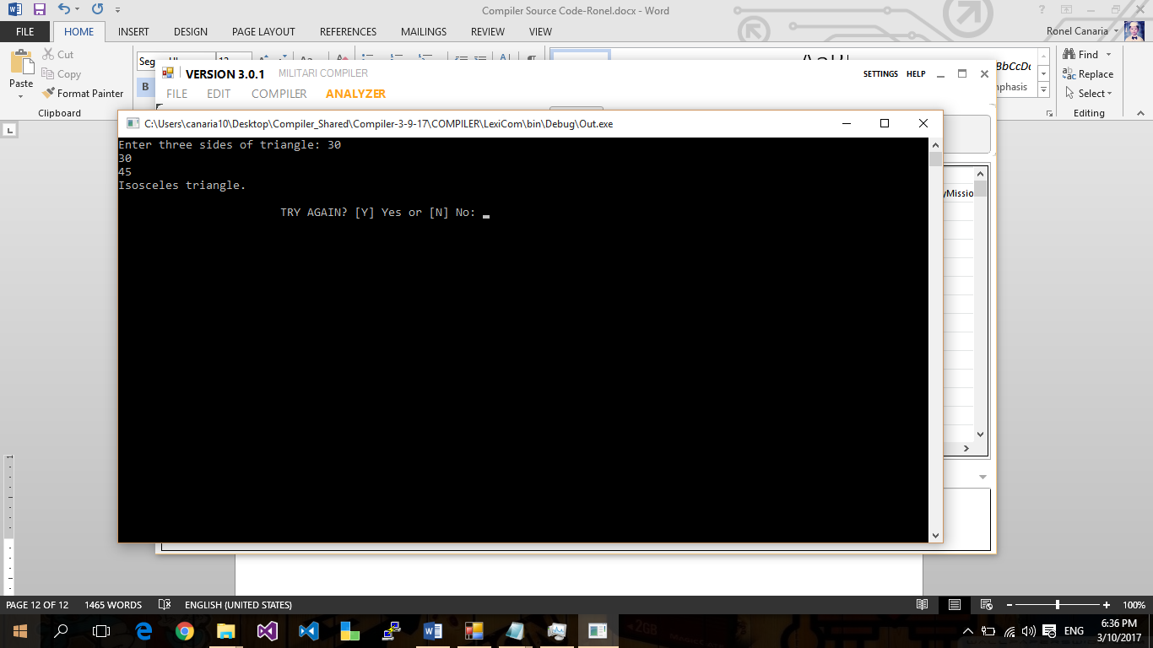**Print Screen:**

**Program # 11:**

**Source Code:**

PrimaryMission() {

unit amount;

unit note500=0, note100=0, note50=0, note20=0, note10=0, note5=0, note2=0, note1=0;

unit choice=0;

go {

commence;

post("Enter amount: ");

capture(#amount);

inorder(amount >= 500) {

note500 = amount/500;

amount = amount - note500 * 500;

}

inorder(amount >= 100) {

note100 = amount/100;

amount = amount - note100 * 100;

}

inorder(amount >= 50) {

note50 = amount/50;

amount = amount - note50 * 50;

}

inorder(amount >= 20) {

note20 = amount/20;

amount = amount - note20 * 20;

}

inorder(amount >= 10) {

note10 = amount/10;

amount = amount - note10 * 10;

}

inorder(amount >= 5) {

note5 = amount/5;

amount = amount - note5 * 5;

}

inorder(amount >= 2) {

note2 = amount /2;

amount = amount - note2 * 2;

}

inorder(amount >= 1) {

note1 = amount;

}

post("Total number of notes = \n");

post("500 = " + note500 + "\n");

post("100 = " + note100 + "\n");

post("50 = " + note50 + "\n");

post("20 = " + note20 + "\n");

post("10 = " + note10 + "\n");

post("5 = " + note5 + "\n");

post("2 = " + note2 + "\n");

post("1 = " + note1 + "\n");

go {

company ch;

post("\n\n\t\t\tTRY AGAIN? [Y] Yes or [N] No: ");

capture(#ch);

inorder((ch = = "Y") || (ch = = "y")) {

note500=0;

note100=0;

note50=0;

note20=0;

note10=0;

note5=0;

note2=0;

note1=0;

choice = 1;

}

otherorder((ch = = "N") || (ch = = "n")) {

choice = 0;

}

order {

post("\n\t\t\tError Input!");

choice = 3;

}

} phase(choice = = 3);

} phase(choice != 0);

post("\n\t\t\tGOODBYE!!");

} deploy();

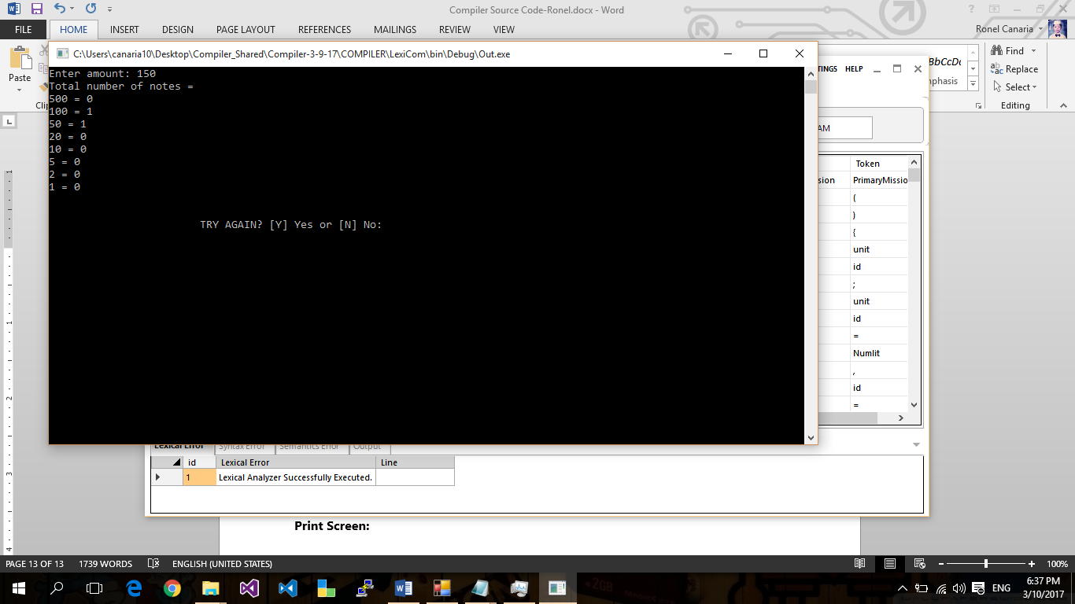**Print Screen:**

**Program # 12:**

**Source Code:**

miss hanoi(unit ndisk, joe source, joe target, joe other) {

inorder(ndisk > 0) {

ndisk=ndisk-1;

hanoi(ndisk, source, other, target);

post("Move disk from" + source + " to " +target+ "\n");

hanoi(ndisk, other, target, source);

}

}

PrimaryMission() {

unit ndisk;

unit choice=0;

go {

commence;

post("Tower of Hanoi!\n");

post("Enter number of disk: ");

capture(#ndisk);

hanoi(ndisk, '1', '2', '3');

go {

company ch;

post("\n\n\t\t\tTRY AGAIN? [Y] Yes or [N] No: ");

capture(#ch);

inorder((ch = = "Y") || (ch = = "y")) {

ndisk=0;

choice = 1;

}

otherorder((ch = = "N") || (ch = = "n")) {

choice = 0;

}

order {

post("\n\t\t\tError Input!");

choice = 3;

}

} phase(choice = = 3);

} phase(choice != 0);

post("\n\t\t\tGOODBYE!!");

} deploy();

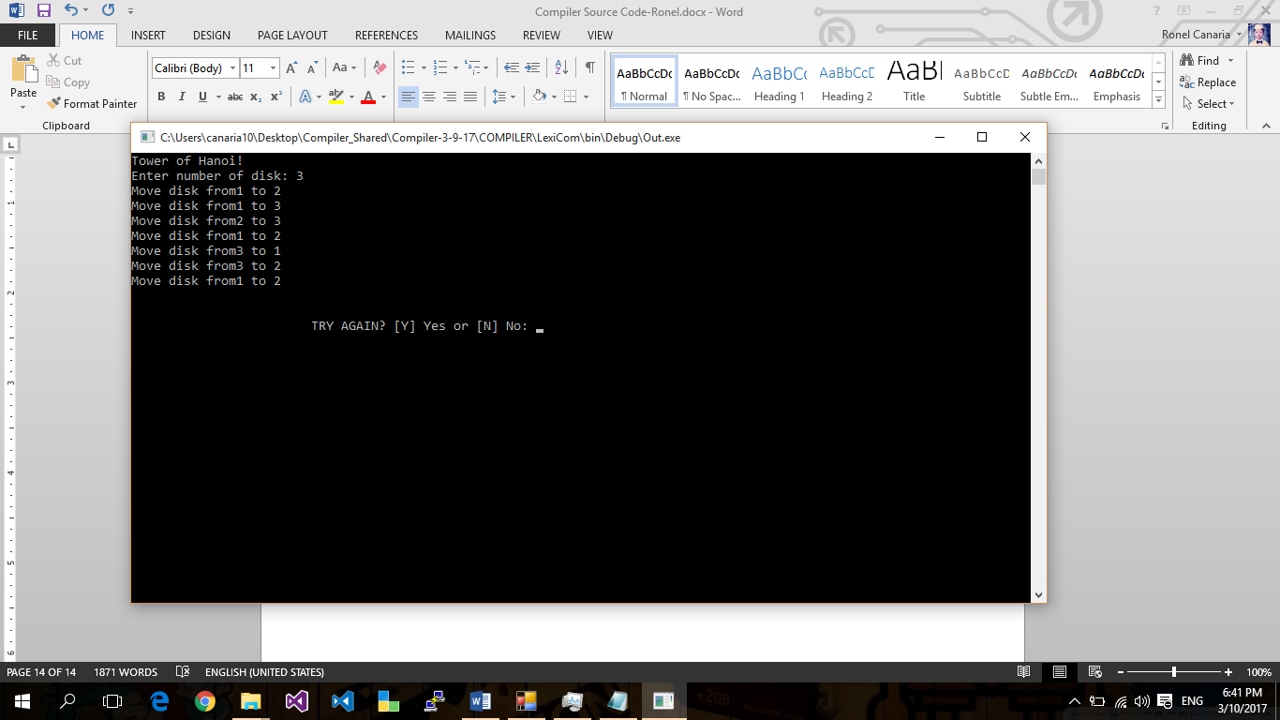**Print Screen:**

**Program # 13:**

**Source Code:**

unit who_wins(company a, company b) {

unit num=0;

inorder((a = = "P") & (b = = "R")) {

num = 1;

}

inorder((a = = "P") & (b = = "S")) {

num = 2;

}

inorder((a = = "R") & (b = = "P")) {

num = 2;

}

inorder((a = = "R") & (b = = "S")) {

num = 1;

}

inorder((a = = "S") & (b = = "R")) {

num = 2;

}

inorder((a = = "S") & (b = = "P")) {

num = 1;

}

backup(num);

}

PrimaryMission() {

unit temp=0;

unit count_A = 0;

unit count_B = 0;

company pl1;

company pl2;

unit choice=0;

go {

commence;

post("ROCK [R], PAPER [P] and SCISSOR's [S] TOURNAMENT!!!\n");

post("Player A: ");

capture(#pl1);

commence;

post("Player B: ");

capture(#pl2);

temp = who_wins(pl1,pl2);

inorder(temp = = 1 ) {

post("A WINS\n");

count_A++;

}

otherorder(temp = = 2 ) {

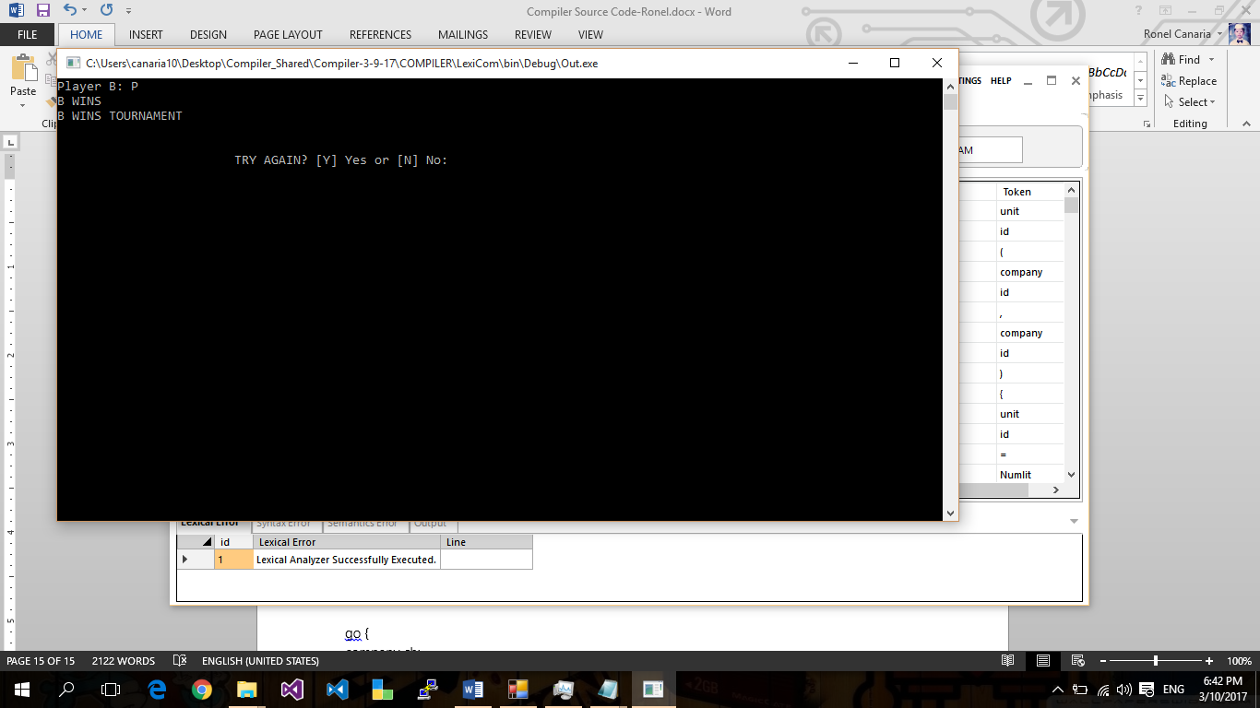post("B WINS\n");

count_B++;

}

order {

post("DRAW\n");

}

inorder(count_A > count_B) {

post("A WINS TOURNAMENT\n");

}

order {

post("B WINS TOURNAMENT\n");

}

go {

company ch;

post("\n\n\t\t\tTRY AGAIN? [Y] Yes or [N] No: ");

capture(#ch);

inorder((ch = = "Y") || (ch = = "y")) {

temp=0;

count_A = 0;

count_B = 0;

pl1 = " ";

pl2 = " ";

choice = 1;

}

otherorder((ch = = "N") || (ch = = "n")) {

choice = 0;

}

order {

post("\n\t\t\tError Input!");

choice = 3;

}

} phase(choice = = 3);

} phase(choice != 0);

post("\n\t\t\tGOODBYE!!");

} deploy();

**Print Screen:**

**Program # 14:**

**Source Code:**

unit arr1[10];

unit arr2[10];

unit arr3[10];

PrimaryMission() {

unit i,j=0,k=0,n,temp;

unit choice=0;

go {

commence;

post("\n\nSeparate odd and even integers in separate arrays:\n");

post("------------------------------------------------------\n");

post("Input the number of elements to be stored in the array :");

capture(#n);

post("Input" + n + "elements in the array :\n");

inquire(i=0;i<n;i++) {

post("element - " + i + ": ");

capture(#arr1[i]);

}

inquire(i=0;i<n;i++) {

temp = arr1[i] % 2;

inorder(temp = = 0) {

arr2[j] = arr1[i];

j++;

}

order {

arr3[k] = arr1[i];

k++;

}

}

post("\nThe Even elements are : \n");

inquire(i=0;i<j;i++) {

post("[" + arr2[i] + "]");

}

post("\nThe Odd elements are :\n");

inquire(i=0;i<k;i++) {

post("[" + arr3[i] + "]");

}

post("\n\n");

go {

company ch;

post("\n\n\t\t\tTRY AGAIN? [Y] Yes or [N] No: ");

capture(#ch);

inorder((ch = = "Y") || (ch = = "y")) {

i=0;

j=0;

k=0;

n=0;

temp=0;

choice = 1;

}

otherorder((ch = = "N") || (ch = = "n")) {

choice = 0;

}

order {

post("\n\t\t\tError Input!");

choice = 3;

}

} phase(choice = = 3);

} phase(choice != 0);

post("\n\t\t\tGOODBYE!!");

} deploy();

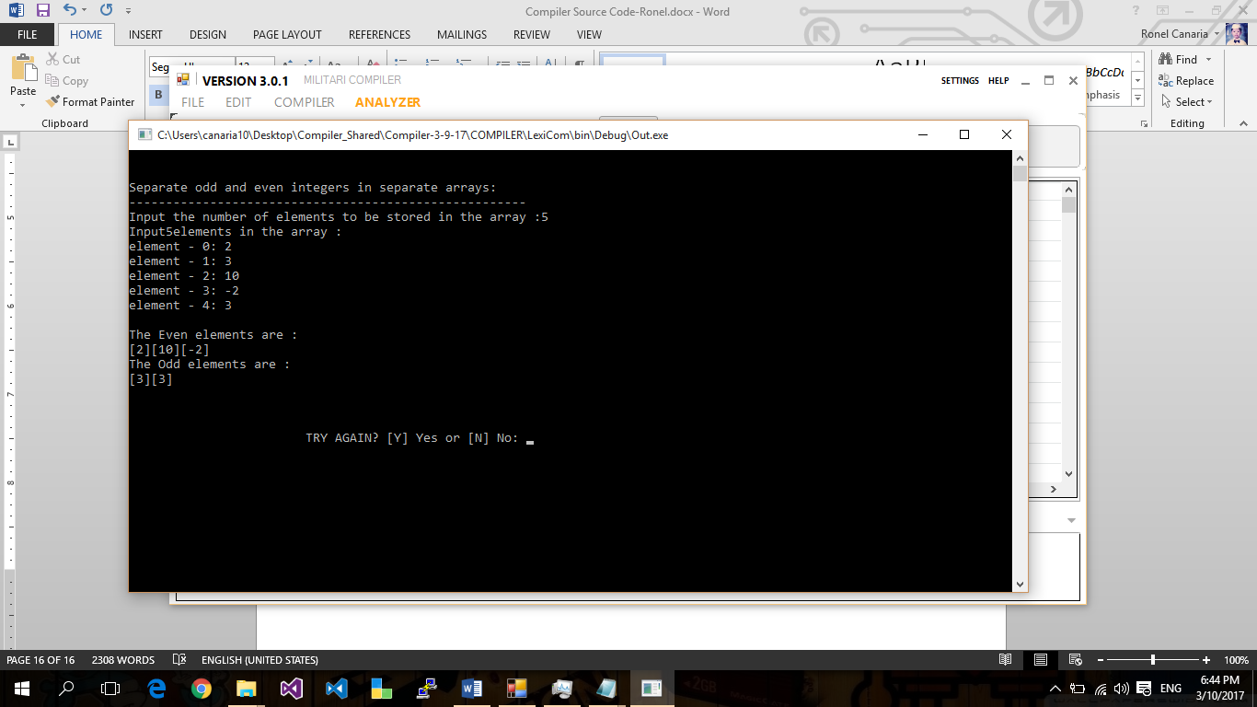**Print Screen:**

**Program # 15:**

**Source Code:**

unit arr[50];

PrimaryMission() {

unit n, i, sum=0;

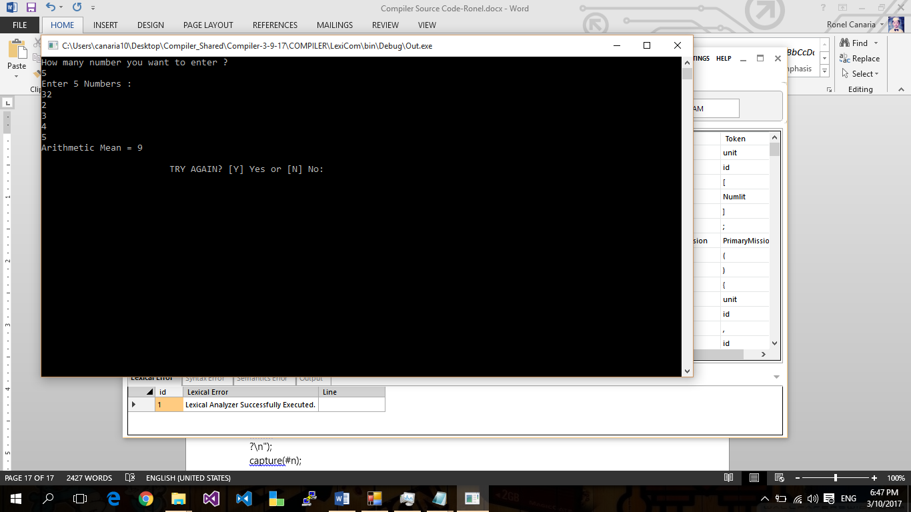unit choice;

go {

commence;

post("How many number you want to enter ?\n");

capture(#n);

post("Enter " + n + " Numbers :\n");

inquire(i=0; i<n; i++) {

capture(#arr[i]);

sum=sum+arr[i];

}

unit armean;

armean = sum/n;

post("Arithmetic Mean = " + armean);

go {

company ch;

post("\n\n\t\t\tTRY AGAIN? [Y] Yes or [N] No: ");

capture(#ch);

inorder((ch = = "Y") || (ch = = "y")) {

n=0;

i=0;

sum=0;

choice = 1;

}

otherorder((ch = = "N") || (ch = = "n")) {

choice = 0;

}

order {

post("\n\t\t\tError Input!");

choice = 3;

}

} phase(choice = = 3);

} phase(choice != 0);

post("\n\t\t\tGOODBYE!!");

} deploy();

**Print Screen:**

**Program # 16:**

**Source Code:**

PrimaryMission() {

unit exponent;

digit base1, result = 1.0;

unit choice;

go {

commence;

post("Enter base and exponent respectively: ");

capture(#base1);

capture(#exponent);

post(base1 + " ^ " + exponent + " = ");

phase(exponent != 0) {

result = result * base1;

exponent--;

}

post(result);

go {

company ch;

post("\n\n\t\t\tTRY AGAIN? [Y] Yes or [N] No: ");

capture(#ch);

inorder((ch = = "Y") || (ch = = "y")) {

exponent=0;

base1=0;

result = 1.0;

choice = 1;

}

otherorder((ch = = "N") || (ch = = "n")) {

choice = 0;

}

order {

post("\n\t\t\tError Input!");

choice = 3;

}

} phase(choice = = 3);

} phase(choice != 0);

post("\n\t\t\tGOODBYE!!");

} deploy();

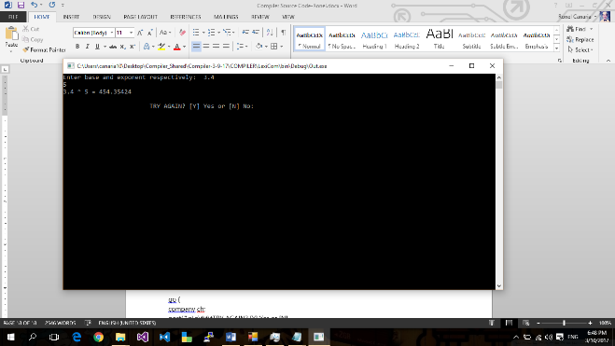**Print Screen:**